Real-Time Absolute Frequency Measurement of CW-THz Wave Based on Dual THz Combs

K. Hayashi¹, H. Inaba^{2,3}, K. Minoshima^{2,4}, and T. Yasui^{1,3}
¹The University of Tokushima, 2-1, Minami-Josanjima-cho, Tokushima, Tokushima 770-8506, Japan
²National Institute of Advanced Industrial Science and Technology, 1-1-1 Umezono, Tsukuba, Ibaraki 305-8563, Japan
³ERATO Intelligent Optical Synthesizer Project, JST, 1-5-1, Chofugaoka, Chofu, Tokyo 182-8585, Japan
⁴The University of Electro-Communications, 1-5-1, Chofugaoka, Chofu, Tokyo 182-8585, Japan
Author e-mail: hayashi@femto.me.tokushima-u.ac.jp http://femto.me.tokushima-u.ac.jp/

Abstract: We demonstrated a frequency measurement of CW-THz wave referring to dual THz frequency comb in real time. The absolute frequency of the CW-THz wave is measured with an accuracy of 3.5*10⁻¹¹ 10ms each.
OCIS codes: (120.3930) Metrological instrumentation; (120.6200) Spectrometers and spectroscopic instrumentation; (300.6320) Spectroscopy, high-resolution; (300.6495) Spectroscopy, terahertz.

1. Introduction
Frequency measurement is the most basic measurement technology in the light and electric waves, but in THz region (wavelength = 30 ~ 3000 μm, frequency = 0.1 ~ 10 THz) which has not been explored for a long time, it has been difficult to measure frequencies in THz region with high accuracy in a room temperature environment. Therefore, we have been researching in THz comb reference type spectrum analyzer which enables high precision frequency measurement at room temperature environment by following the procedures described as below: First, generate photocarrier terahertz frequency comb (PC-THz comb) in photoconductive antenna (PCA). Second, mix CW-THz wave and the generated PC-THz comb. Finally, beat down the resultant signal to the RF region by photoconductive mixing [1, 2].
However, in conventional absolute frequency measurement using THz spectrum analyzer, it is necessary to measure beat frequencies before and after shifting comb interval ( = repetition frequency ) in order to determine the comb mode number that is nearest to the CW-THz wave. This two-step measurement has been an obstacle to the real-time measurement. In this paper, the absolute frequency of fluctuating CW-THz wave has been determined by measuring the beat frequencies simultaneously using two PC-THz combs with different comb intervals. Furthermore, we report here that we realized high speed absolute frequency measurement by calculating the instantaneous frequency using a Hilbert transform [3].
2. Principle
Our THz spectrum analyzer is based on a heterodyne technique based on photoconductive mixing. Compared with the electrical heterodyne technique, a key difference here is that the PCA is used as a heterodyne receiver. This results in high, broadband spectral sensitivity in the THz region without the need for cooling. Another difference is the use of a PC-THz comb whose frequency covers from the sub-THz to the THz region as a local oscillator with multiple frequencies.
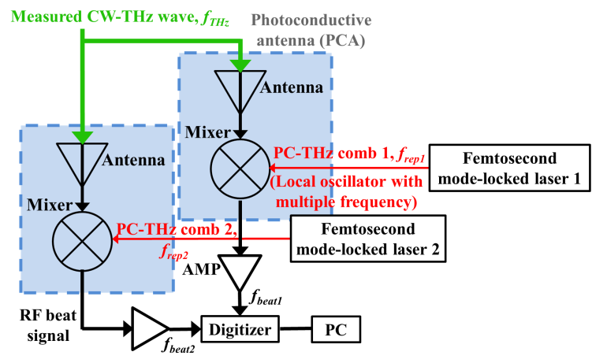
Figure 1 shows the frequency measurement principle using dual PC-THz comb. f_{rep1} and f_{rep2} of two femtosecond fiber lasers (center wavelength = 1550 nm, pulse duration = 50 fs) are stabilized at 100,000,000 Hz and 100,001,000 Hz, respectively, by referencing to a Rb frequency standard. The current beat signal (f_{beat1}, f_{beat2}) is generated by photoconductive mixing when laser beam and CW-THz wave (f_{THz}) enter the PCA. This signal is amplified by current preamplifier and acquired the time waveform by digitizer (resolution = 14 bit, sampling rate = 100 MHz). Acquired signal is transformed on PC using a Hilbert transform, then each instantaneous values of f_{beat1} and f_{beat2} are obtained. The order m can be determined using the following equation.
Fig.1. Principle of measurement.

$$m={|f_{beat1}-f_{beat2}|}/{|f_{rep1}-f_{rep2}|} (1)$$
The absolute frequency of the CW-THz wave is calculated as follow
fTHz=mfrep1-fbeat1 >0
fTHz=mfrep1+fbeat1 (fbeat1-fbeat2/frep1-frep2)<0 (2)
3. Result
Figure 2(a) shows the instantaneous frequencies of two beat signals calculated by a Hilbert transform. The sampling rate of the digitizer is 100 MHz, and a data set of f_{beat1} and f_{beat2} was acquired every 10ms during 1 s. These results show that the f_{beat1} and f_{beat2} fluctuated between 50 MHz ± 20 Hz. Figure 2(b) shows the result obtained by applying Eqs. 1 and 2 to Fig. 2(a); the absolute frequency of the CW-THz wave fluctuating within 0.1 THz ± 20 Hz was measured within quickly and correctly.
Next, the absolute frequency of CW-THz wave is changed extending across comb intervals in order to evaluate its adaptability with respect to large fluctuation of f_{THz}, such as the mode hop. Figure 3 shows the result. Orange lines show the order of comb mode (m) and green lines show the absolute frequency of the CW-THz wave (f_{THz}). From the figure, the m increases by 2 when the f_{THz} increase by 200 MHz, then the m decreases by 4 orders when the f_{THz} decreases by 400 MHz. This experimental outcome leads to the recognition that not only small changes of the f_{THz} as shown in Fig. 2, but also large changes of f_{THz} across the comb modes can be measured in real time. As a result, it will be possible to measure the absolute frequency of the CW-THz source with large fluctuation in real time. In addition, f_{THz} which is determined by this technique coincides with a set precision of 10⁻¹¹ to f_{THz}.

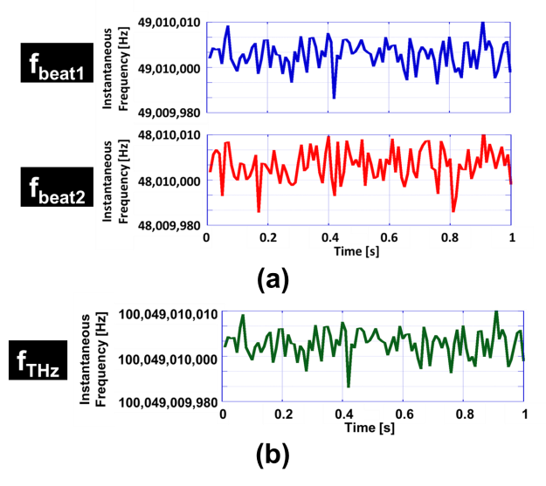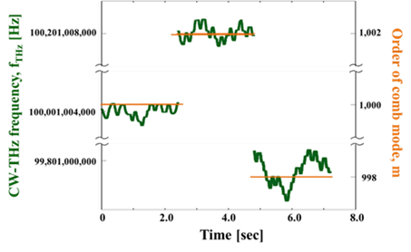

Fig.2. Fluctuations of f_{beat1}, f_{beat2}, and f_{THz}. Fig.3. Real time monitoring of largely fluctuated f_{THz}.

4. Conclusions
We have measured the absolute frequency of the CW-THz wave in real time using the dual PC-THz comb. Achieved measurement rate is 100 Hz and accuracy is 3.5*10⁻¹¹. In addition, we have shown from the actual measurement that changes in large absolute frequencies extending across comb modes can also be followed in real time. As a result, the frequency characterization of the CW-THz source whose output frequency changes from moment to moment becomes possible.

[1] S. Yokoyama, R. Nakamura, M. Nose, T. Araki, and T. Yasui, "Terahertz spectrum analyzer based on a terahertz frequency comb," Opt. Express 16, 13052-13061 (2008).
[2] T. Yasui, R. Nakamura, K. Kawamoto, A. Ihara, Y. Fujimoto, S. Yokoyama, H. Inaba, K. Minoshima, T. Nagatsuma, and T. Araki, "Real-time monitoring of continuous-wave terahertz radiation using a fiber-based, terahertz-comb-referenced spectrum analyzer," Opt. Express 17 17034-17043 (2009).
[3] H. Füser, R. Judaschke, and M. Bieler, “High-precision frequency measurements in the spectral region using an unstabilized femtosecond laser,” Appl. Phys. Lett. 99, 121111(2011).

