R. Ichikawa¹, H. Kimura¹, K. Hayashi¹, H. Inaba^{2,3}, K. Minoshima^{3,4}, and T. Yasui^{1,3}
¹The University of Tokushima, Tokushima, Tokushima 770-8506, Japan
²National Institute of Advanced Industrial Science and Technology, Tsukuba, Ibaraki 305-8563, Japan
³JST-ERATO Intelligent Optical Synthesizer Project, Chofu, Tokyo 182-8585, Japan
⁴The University of Electro-Communications, Chofu, Tokyo 182-8585, Japan

Extraction of Beat Signal between Dual THz Combs Using Dual THz Spectrum Analyzers
Abstract—It is crucial in asynchronous-optical-sampling THz time-domain spectroscopy or dual THz comb spectroscopy to suppress the timing jitter of the mode-locked frequency between two femtosecond lasers or frequency fluctuation of a beat signal between two THz combs because the fluctuation of them distorts the linearity of frequency scale in the spectrum. In this paper, dual THz spectrum analyzers were effectively used to extract a beat signal between dual THz combs around 0.1 THz. The resulting beat signal has a linewidth below 1Hz and a signal-to-noise ratio of 20 dB. Furthermore, the extracted beat signal was used to suppress the remained timing jitter effectively.

INTRODUCTION
U
SE of two stabilized femtosecond lasers with slightly mismatched mode-locked frequencies (f_{rep1}, f_{rep2}) for generation and detection of THz radiation enables an asynchronous-optical-sampling THz time-domain spectroscopy (ASOPS-THz-TDS) [1-3] or dual THz comb spectroscopy [4, 5]. Attractive features in these methods include high resolution and accuracy in the broadband THz spectroscopy. However, in reality, frequency fluctuation of a beat signal ∆f_{rep} (= f_{rep2} - f_{rep1}) between those two THz combs, corresponding to timing jitter of the mode-locked frequency between two femtosecond lasers, limits the spectral accuracy and resolution because a frequency scale of the spectrum is downscaled to RF region based on a ratio of f_{rep1} to ∆f_{rep}. Even though the f_{rep1} and f_{rep2} can be well stabilized by direct control of them, ∆f_{rep} is still flcutuated due to its indirect control via direct control of f_{rep1} and f_{rep2}. If flucuation of ∆f_{rep} can be extratced precisely, the remaing fluctuation of the beat signal will be well supressed by direct control of ∆f_{rep}. To this end, a higher harmonic component of ∆f_{rep} should be extracted because the ∆f_{rep} is too low frequency to use for precise laser control. In this paper, we extracted a 1071-th harmonic component of ∆f_{rep}, or a beat signal between two THz combs around 0.1 THz. Furthermore, the extracted beat signal was used to suppress the timing jitter of the mode-locked frequency between two femtosecond lasers.

Method
We extracted a beat signal between dual THz combs using dual THz spectrum analyzers as shown in Fig. 1(a). THz spectrum analyzer is based on a heterodyne technique based on photoconductive mixing [6, 7]. Compared with the electrical heterodyne technique, a key difference here is the use of a photocarrier THz (PC-THz) comb, whose frequency covers from the sub-THz to the THz region, as a local oscillator with multiple frequencies. When two stabilized femtosecond fiber laser lights (center wavelength = 1550 nm, pulse duration = 50 fs, f_{rep1} = 100,000,000 Hz, f_{rep2} = 100,000,010 Hz) are incident onto two independent photoconductive antennae (PCA1 and PCA2), two PC-THz combs with different frequency intervals of f_{rep1} and f_{rep2} are induced in PCA1 and PCA2 as shown in Fig. 1(b). Then, when CW-THz wave (f_{THz} = 107.1 GHz) is incident onto both PCA1 and PCA 2, two beat signals with f_{beat1} (= f_{THz} – mf_{rep1}) and f_{beat2} (= f_{THz} – mf_{rep2}) are generated as PCA current signals, where m is the order of comb mode nearest in frequency to f_{THz}. Finally, we obtained the beat signal between two PC-THz comb (mf_{rep2} – mf_{rep1} = m∆f_{rep}) by electrically mixing these two beat signals and low-pass filtering after amplification.
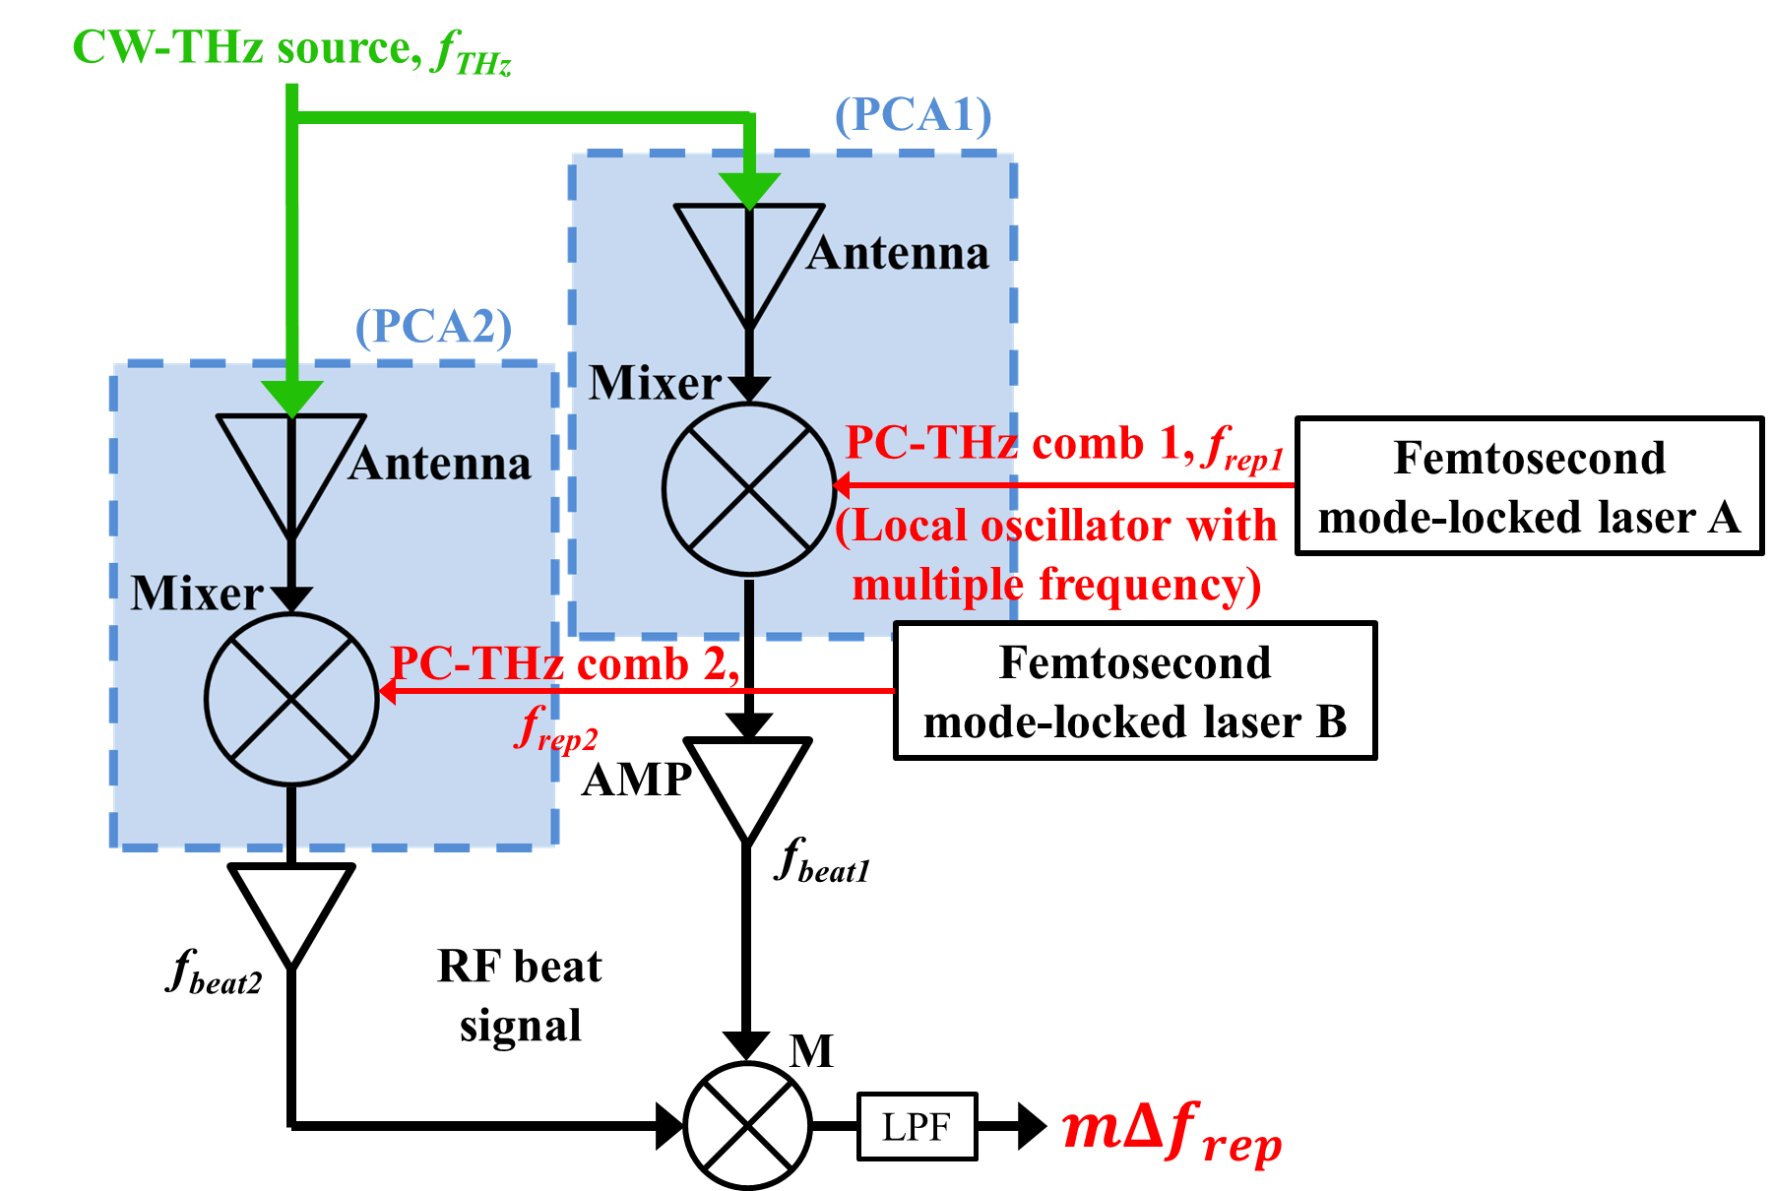
(a)
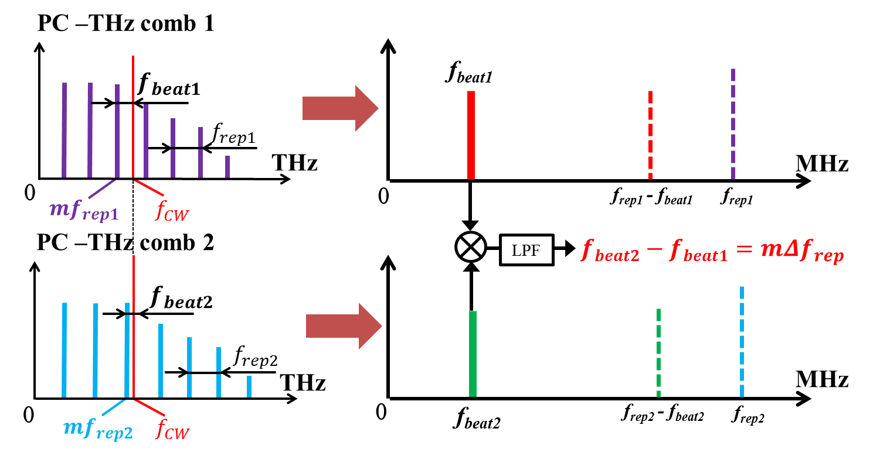
(b)
Fig. 1. (a) Experimental setup and (b) spectral behavior of dual THz spectrum analyzers.

Results
Figure 2 shows an RF spectrum of a beat signal between dual PC-THz combs around 0.1 THz. The signal-to-noise ratio of the beat signal was achieved to 20 dB, which is sufficient to use as a control signal for laser stabilization. On the other hand, the extracted beat signal has a linewidth below 1 Hz which is limited by RBW of 1Hz in RF spectrum analyzer. The narrow-linewidth beat signal sensitively reflects the timing jitter between dual PC-THz combs.
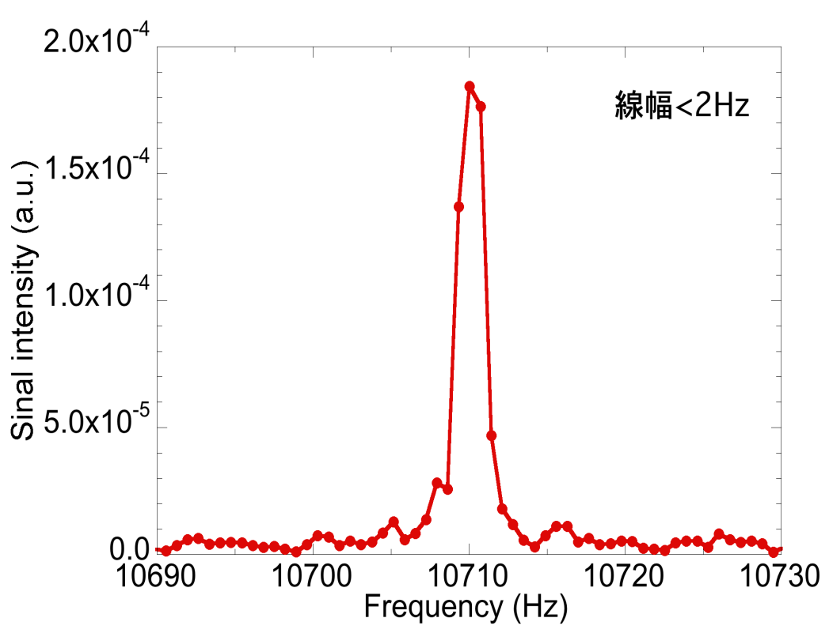

Fig. 2. RF spectrum of a beat signal between dual PC-THz combs around 0.1 THz (RBW = 1 Hz).

Figure 3 shows a frequency fluctuation of the beat signal with respect to gate time. The frequency fluctuation for free-running, dual femtosecond lasers is shown as a black line, indicating a little increase of the frequency fluctuation with respect to the gate time. For reference, the frequency fluctuation for direct control of f_{rep1} and f_{rep2} is shown as blue plots. Comparison between them indicated that the direct control of f_{rep1} and f_{rep2} reduce the fluctuation of the beat frequency. To further reduce the timing jitter, the beat signal was used to control f_{rep2} so that m∆f_{rep} is constant while f_{rep1} is fixed at a certain value. The resulting frequency fluctuation was indicated as red plots. Such direct control of f_{rep1} and m∆f_{rep} suppressed the timing jitter effectively and contribute to improve the spectral resolution and accuracy in the ASOPS-THz-TDS and dual THz comb spectroscopy.
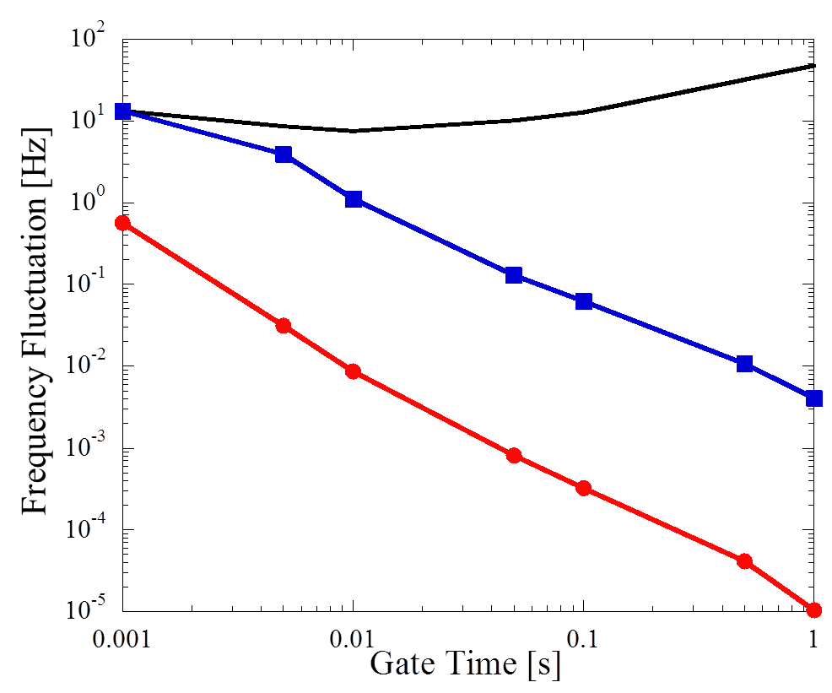
Fig. 3. Frequency fluctuation of beat signal with respect to gate time for free-running dual femtosecond lasers, direct control of f_{rep1} and f_{rep2}, and control of f_{rep1} and m∆f_{rep}.

Summary

Use of dual THz spectrum analyzers enables us to extract a beat signal between dual PC-THz combs around 0.1 THz. The extracted beat signal will be used not only to suppress the remained timing jitter effectively but also to combine an adaptive sampling method using two free-running lasers [8] with dual THz comb spectroscopy.

References
[1]. T. Yasui, E. Saneyoshi and T. Araki, "Asynchronous optical sampling terahertz time-domain spectroscopy for ultrahigh spectral resolution and rapid data acquisition", Appl. Phys. Lett., Vol. 87, art. 061101 (2005).
[2]. T. Yasui, M. Nose, A. Ihara, K. Kawamoto, S. Yokoyama, H. Inaba, K. Minoshima, and T. Araki, "Fiber-based, hybrid terahertz spectrometer using dual fiber combs," Opt. Lett., Vol. 35, pp. 1689-1691 (2010).
[3]. T. Yasui, K. Kawamoto, Y.-D. Hsieh, Y. Sakaguchi, M. Jewariya, H. Inaba, K. Minoshima, F. Hindle, and T. Araki, "Enhancement of spectral resolution and accuracy in asynchronous-optical-sampling terahertz time-domain spectroscopy for low-pressure gas-phase analysis," Opt. Express Vol. 20, pp. 15071–15078 (2012).
[4]. Y.-D. Hsieh, Y. Iyonaga, Y. Sakaguchi, S. Yokoyama, H. Inaba, K. Minoshima, F. Hindle, Y. Takahashi, M. Yoshimura, Y. Mori, T. Araki, and T. Yasui, "Terahertz comb spectroscopy traceable to microwave frequency standard," IEEE Trans. Terahertz Sci. Tech., Vol. 3 , pp. 322-330 (2013).
[5]. Y.-D. Hsieh, Y. Iyonaga, Y. Sakaguchi, S. Yokoyama, H. Inaba, K. Minoshima, F. Hindle, T. Araki, and T. Yasui, "Spectrally interleaved, comb-mode-resolved spectroscopy using swept dual terahertz combs,” Sci. Reports, Vol. 4, art. 3816 (2014).
[6]. S. Yokoyama, R. Nakamura, M. Nose, T. Araki, and T. Yasui, "Terahertz spectrum analyzer based on a terahertz frequency comb", Opt. Express, Vol. 16, pp. 13052-13061 (2008).
[7]. T. Yasui, R. Nakamura, K. Kawamoto, A. Ihara, Y. Fujimoto, S. Yokoyama, H. Inaba, K. Minoshima, T. Nagatsuma, and T. Araki, "Real-time monitoring of continuous-wave terahertz radiation using a fiber-based, terahertz-comb-referenced spectrum analyzer", Opt. Express, Vol. 17, pp. 17034-17043 (2009).
[8] T. Ideguchi, A. Poisson, G. Guelachvili, N. Picque, and T. W. Hansch, "Adaptive real-time dual-comb spectroscopy", Nat. Comm., Vol. 5, art. 3375 (2014).

