Serial time-encoded amplified image for real-time observation of fast dynamic phenomena
PD Yi-Da Hsieh
Introduction
Optical imaging is a widespread and versatile diagnostics and inspection tool in use today. Although most of the current research in imaging is aimed at improving the spatial resolution to below the diffraction limit, there are numerous applications that demand improvement in temporal resolution. Imaging systems with high temporal resolution are needed to study rapid physical phenomena ranging from shock waves, including extracorporeal shock waves used for surgery, to diagnostics of laser fusion and fuel injection in internal combustion engines. High-speed imaging is becoming increasingly important in microscopy because on the micrometer scale even slow-moving phenomena require high temporal resolution. The CCD or CMOS imager is by far the most widely deployed optical imaging technology. It offers a spatial resolution of a few micrometers, a large number of pixels and relatively low cost. Typical imagers used in consumer electronics have frame rates of 30 Hz, although high-end versions can operate at rates on the order of 1 kHz by reducing the number of pixels that are read out from the arrays.
Although CCD imagers will continue to be the most widely used imaging modality and pump–probe experiments will remain a powerful tool for studying fast repetitive events, a new and complementary imaging modality that can capture the dynamics of fast single-shot or random events is clearly needed. Serial time-encoded amplified microscopy (STEAM) technology is a new approach to imaging that provides such a capability [1].
Amplified dispersive Fourier transformation [2, 3]
The key point in STEAM is using Dispersive Fourier transformation (DFT) for optical imaging and image amplification. DFT is a powerful method that overcomes the speed limitation of traditional spectrometers and hence enables fast real-time spectroscopic measurements.
- Method of DFT
The principal requirement for DFT is a sufficiently large and linear GVD such that the frequency-to-time mapping process occurs without distortion. DFT is conceptually depicted in Fig. 1a. The dispersive Fourier transformer consists of a dispersive element with a large group velocity dispersion (GVD) and a photodetector. When a train of optical pulses enters the dispersive element, the spectrum of each pulse is mapped to a temporal waveform by the large GVD in the dispersive element. The definite advantage of DFT over conventional grating-based spectrometers is its ability to use the dispersive element as a gain medium for simultaneous optical amplification of the spectrum.
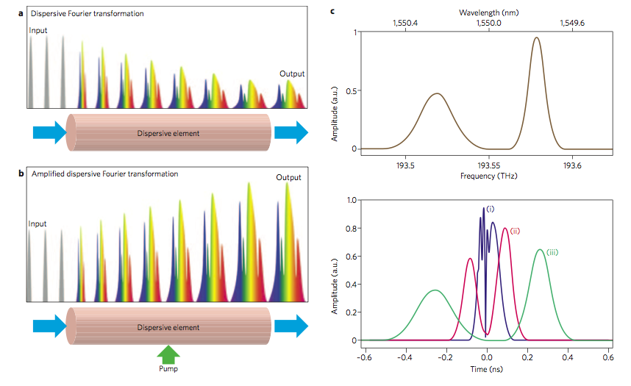
Fig. 1. Dispersive Fourier transformer.
With distributed optical amplification in the dispersive fiber (Fig. 1b), this process, known as ‘amplified’ DFT, overcomes the fundamental three-way trade-off in spectroscopic measurements between sensitivity, speed and spectral resolution that exists in space-domain spectroscopy. Various methods for DFT have been proposed and demonstrated over the past decade to cover different spectral bands (centered about 800 nm, 1,000 nm and 1,550 nm with ~100 nm optical bandwidth). A typical experimental demonstration of DFT is shown in Fig. 2d, which indicates a one-to-one mapping between the optical wavelength (frequency) and time. The most common approach is the use of standard single-mode fibers such as long-haul transmission fibers, dispersion-compensation fibers (DCFs) and small-core fibers (Fig. 2a). Other methods for DCF include the use of chirped fiber Bragg gratings (CFBGs, Fig. 2b), large spatial chirps, and chromo-modal dispersion (CMD, Fig. 2c). Roughly speaking, the DCF, SMF-28 fiber and CFBG are all ideal choices for implementing DFT in the ~1,550 nm spectral band, whereas the small-core fiber, CMD and CFBG are ideal for shorter-wavelength bands of 800–1,000 nm.

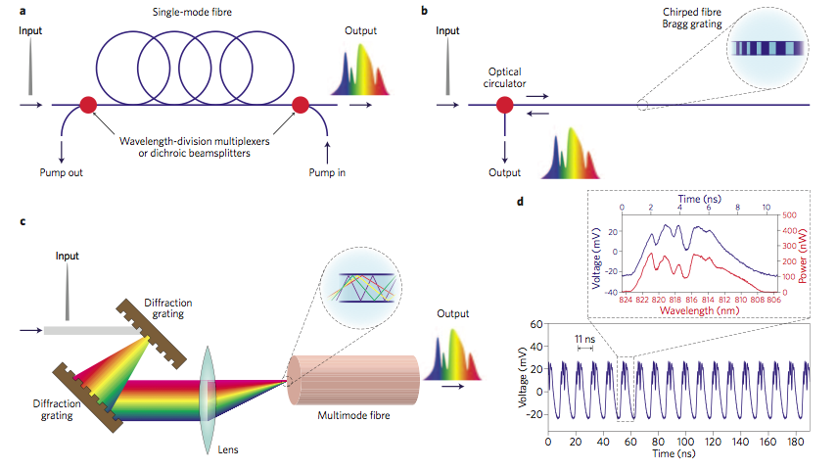
Fig. 2. Methods for dispersive fourier transformation.

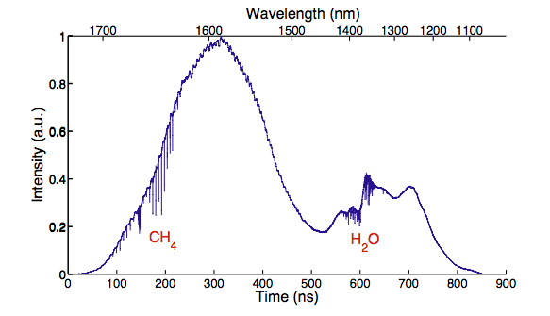
DFT’s first and most obvious application is real-time spectroscopy. DFT-based spectroscopy is realized by using DFT as a fast single-shot spectrometer, and has been broadly employed for various types of spectroscopic measurements. In this experiment, the broadband absorption spectroscopy of a gas mixture, in which the broad 600 nm bandwidth covered 1,100–1,700 nm for simultaneous identification of CH4 and H2O (Fig. 3). Here, the nonlinearity of the GVD in the dispersive fiber was corrected to calibrate the wavelength-to-time mapping process.
Fig. 3. Broadband absorption spectrum of a gas mixture (CH4 and H2O)

Serial time-encoded amplified microscopy (STEAM)
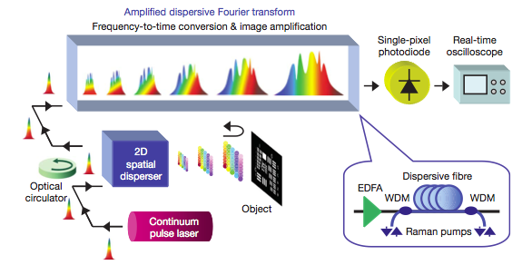
The key feature of the STEAM camera is the mapping of a 2D image into an amplified serial time-domain waveform. This is achieved by first encoding the 2D spatial information of an object onto the spectrum of a broadband (continuum) pulse (Fig. 4) using a pair of orthogonally oriented spatial dispersers. The encoding occurs when the spatially dispersed pulse is reflected off the object, after which it re-enters the disperser, where the wavelengths are recombined. An optical circulator directs the pulses into an optically amplified dispersive Fourier transformer, the details of which are shown in the inset of Figure. 4. Dispersion-compensating fiber (DCF) is used to perform the dispersive Fourier transform and Raman amplification of the image because it offers high dispersion and low loss as well as a high Raman gain coefficient. Broadband gain can be achieved by pumping with multiple lasers or an incoherent light source.
The amplified dispersive Fourier transform maps the spectrum of an optical pulse into a time-domain waveform, allowing the spectrum to be viewed on a conventional electronic receiver (Fig. 5a). It eliminates the traditional spectrometer, including the prism or diffraction grating and the CCD, and makes it possible to capture the spectrum with a single-pixel photodetector. At the same time, it overcomes the receiver noise level by amplifying the signal while it is still in the optical domain. Optical image amplification is vital for high-speed imaging because the noise power present in any measurement increases inversely with the integration time. Without this amplification, the image would not be visible because the signal would lie below the thermal noise level of the photodetector, as can be seen in Fig. 5b. A high-power laser source can also overcome the detector noise; however, this is not a desirable solution as it can potentially damage the object being imaged, particularly in microscopy, in which the light has to be focused onto a very small area. The optical image amplification made possible by the serialization of the 2D image overcomes this problem. Operation of the STEAM camera is illustrated in Fig. 5c. The figure shows the image of a 2D object captured in the time domain using a real-time oscilloscope. The reconstruction of the 2D spatial image from a one-dimensional (1D) temporal data stream involves the trivial task of simply sorting the 1D vector into a 2D matrix and is described further in Methods. The results clearly demonstrate a modality for optical imaging that is amenable to high-speed operation. The 2D frame corresponds to the envelope of the temporal pulse shown in Fig. 5a. Frames are repeated at intervals of 163 ns (Fig. 5d)— a value that corresponds to a frame rate of 6.1 MHz, which is a record for continuous real-time imaging.
Fig. 4. STEAM camera.
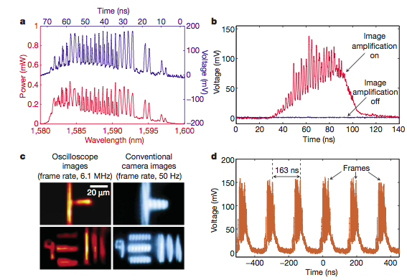
As a demonstration of the ultrafast real-time imaging capability of the STEAM camera, we used it to capture the dynamics of laser ablation. Laser ablation is a ubiquitous technology that is used in laser surgery, laser cutting and micromachining, and laser-induced breakdown spectroscopy. The ablation was performed with a mid- infrared pulse laser (with a pulse energy of 6 mJ and a pulse width of 5 ns) focused at an angle onto a sample consisting of a bilayer of aluminum and silicon dioxide deposited on top of a silicon-on- insulator substrate. The imaging pulse train of the STEAM camera was normally incident to the surface of the sample (Fig. 6a). Figure 6b shows the real-time sequence of the images with a frame-repetition period of 163 ns. The entire frame sequence corresponding to the dynamics (laser-induced mass ejection) caused by the single ablation pulse was captured in real time. Further analysis of the surface reflectivity change shows there to be a finite time delay between the pulse excitation and the sudden decrease in the surface reflectivity, which correlates with ejection of material from the sample (Fig. 6c) and is a clear signature of the phase-explosion effect that is the hallmark of laser ablation. Our results also show the depth profile of the sample, and confirm that the laser excitation pulse ablated the aluminum and silicon dioxide layers and exposed the underlying silicon layer. This demonstration firmly establishes the ability of the STEAM camera to monitor fast dynamical processes in real time.
Fig. 5. Basic operation of the STEAM camera.
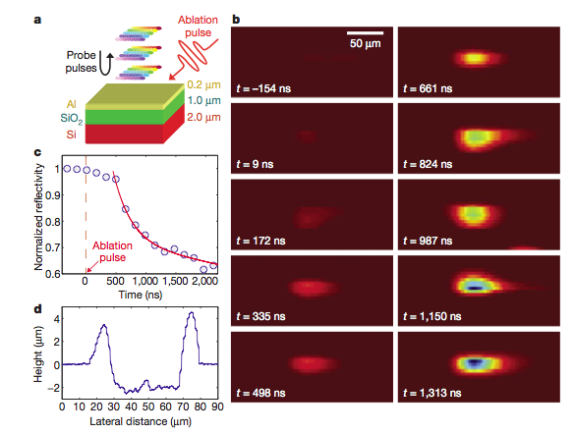
Fig. 6. Schematic of experimental set-up, real-time STEAM images and characterization of the laser ablation experiment.

High-throughput single-microparticle imaging flow analyzer [4]
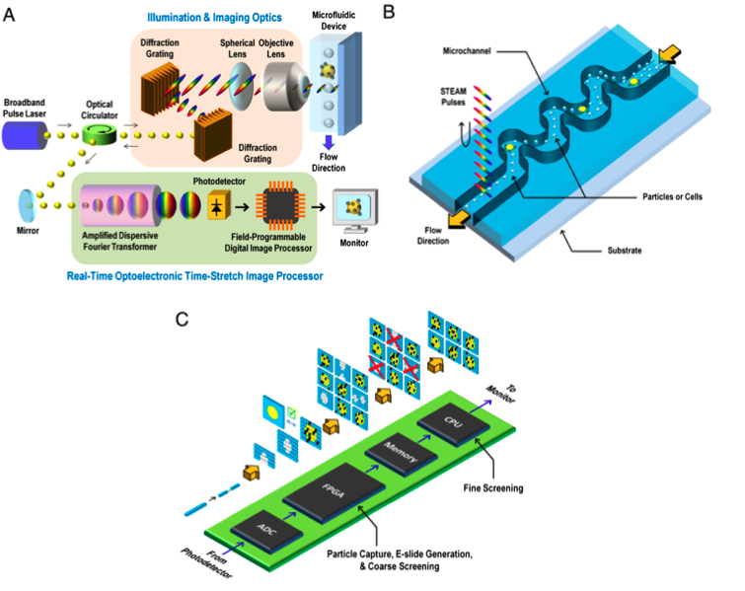
The STEAM flow analyzer consists of three subsystems: (i) the STEAM camera (Fig. 7A), (ii) the microfluidic device (Fig. 7B), the real-time optoslectronic time –stretch image processor (Fig. 7C). The STEAM flow analyzer operates in three steps. First, particles are controlled to flow at a uniform velocity and focused and ordered by inertial lift forces in the microfluidic channel. Second, the STEAM camera takes images of the fast-flowing particles. Finally, the real-time optoelectronic time-stretch image processor processes the images optically and electronically and then performs automated particle screening in real time.
Fig. 7. STEAM flow analyzer.
The STEAM camera first captures fast sequential images with laser pulses and then stretches image-encoded pulses in time so that they can be digitized and processed in real time. During the time-stretch process, images are also optically amplified to overcome the thermal noise inherent in photon-to-electron conversion. In the first step, a pair of diffraction gratings spatially disperses the broadband optical pulse into a rainbow de- signed to capture 1D line scans of particles flowing through the channel. The temporal duration of these pulses is 27 ps (shutter speed), and they occur at a repetition rate of 36.7 MHz (line scan rate), while the average illumination power is 500 μW. The back- reflected pulses from the microfluidic device are directed via an optical circulator toward the real-time optoelectronic time- stretch image processor followed by the high-speed photodetector and the field-programmable digital image processor. Two-dimensional E-slides are then constructed from the digitized 1D frames and made available for screening. Fig. 8 shows E-slides of fast-flowing particles of various species in the microfluidic channel captured by the STEAM flow analyzer. Here the particles were controlled to flow at a uni- form speed of 4 m∕s, which corresponds to a throughput of 100,000 particles∕s—a very fast flow, but motion blur is absent in the images due to the ultrafast shutter speed of the STEAM camera (27 ps). For comparison, Fig. 8 also shows images of the same types of particles under the same flow conditions captured by a state-of-the-art CMOS camera. These images show that the CMOS camera’s lower shutter speed (1 μs) and lack of optical image amplification significantly reduced the sensitivity and caused motion blur in the images, rendering the camera unable to classify particles reliably. For further comparison, stationary particles of the same types on a glass slide were obtained under a conventional microscope with a CCD camera with a much longer exposure time (shutter speed) of 17 ms (Fig. 8). Despite the fact that the STEAM camera is many orders of magnitude faster than the CCD camera, the two cameras share similar image quality.
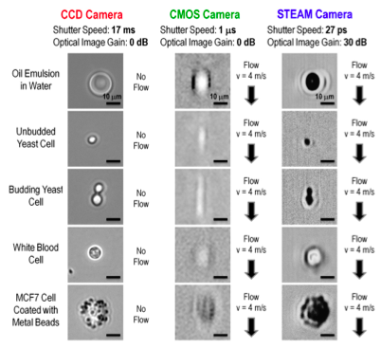
Fig. 8. Performance of the STEAM camera and comparison with a conventional CCD camera and a CMOS camera.

- Rare Cell Detection with the High-Throughput Imaging Flow Analyzer.
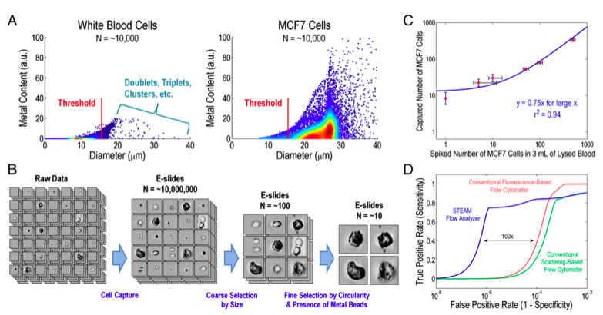
To further show the utility of the STEAM flow analyzer, we used it to demonstrate rare cell detection. Such rare cells can be identified by a combination of morphological (i.e., size, circularity, and clustering) and biochemical (i.e., surface antigens) markers. Here our model for rare cells is the MCF7 cell line (breast cancer) spiked in blood. Red blood cells are lysed with a hypotonic lysing agent while MCF7 cells are fixed with formaldehyde and coated with metal beads with a diameter of 1 μm via an antibody to EpCAM (a cell surface molecule that exists on the surface of epithelial cells but not on the surface of blood cells). Our observation under a conventional microscope indicates that approximately 80% of MCF7 cells are coated with 5–20 metal beads.
Fig. 9. Rare cell detection with the STEAM flow analyzer.

The threshold for the size-based selection is set such that smaller MCF7 cells are also selected at the expense of detecting larger white blood cells (Fig. 4A). Yet, this process efficiently rejects more than 99.9995% of white blood cells, all residual red blood cells, and all free-floating metal beads, leaving only a small number of false positive events (on the order of 100 per mL of lysed blood) along with true positive events (Fig. 4B). Their statistical analysis of the capture efficiency indicates that the field-programmable digital image processor can identify extremely rare cells with a high efficiency of 75% (limited by the imperfect coating efficiency and missing smaller MCF7 cells in the FPGA selection process) (Fig. 4C). Furthermore, our receiver operating characteristic (ROC) curve analysis of the results indicates that our method is sufficiently sensitive for detection of approximately one MCF7 cell in a million white blood cells and is 100 times better in terms of false positive rate than the conventional flow cytometer (Fig. 4D) yet without sacrificing throughput. Here all the measurements were performed at a throughput of 100,000 cells∕s, corresponding to screening of 10 mL of lysed blood in less than 15 min.
Summary
High-speed instruments capable of capturing fast transient events are seeing increasing demand as the physical processes of interest become more complex. With its ability to perform fast continuous measurements, STEAM is expected to be useful for high-throughput screening and studying non-repetitive rare phenomena for which conventional pump–probe methods fall short due to their requirement for repetitive events.
Reference
[1] K. Goda, et al. (2009) Nature, 458: 1145.
[2] J. Hult, et al. (2007) Opt. Exp., 15: 11385.
[3] K. Goda, et al. (2013) Nat. Phontonics, 7: 102.
[4] K. Goda, et al. (2012) Proc. Natl. Acad. Sci., 109: 11630.

